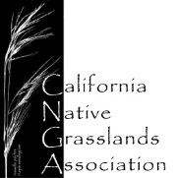
Learning About California Grasslands
Lesson Title: Birds in California Grasslands: Western Meadowlark
Grade level: Early elementary: pages 1 and 2; late elementary: pages 1 through 3.
Lesson Length: 15 to 30 minutes depending on number of pages completed.
Preparation and Materials: Copies of worksheet, pencil and crayons, colored pencils, or markers.
Lesson Goal: Students practice reading comprehension while learning about a grassland species. Students follow instructions to match colors with numbers.
Lesson Description: Lower early elementary: The teacher reads the paragraph to the students along with instructions. Students follow instructions by reading the table and coloring the numbered areas on the meadowlark with the color indicated on the table. The teacher will then read the questions and lead a discussion about meadowlarks. Students may write their answers.
Upper early elementary: Students read the paragraph and complete the lesson by coloring and answering the questions.
Lesson Objectives: Students will learn about the Western Meadowlark’s habitat and behavior. They will learn to identify meadowlarks by their colors and markings.
Lesson Background: Western and eastern meadowlarks have shown a steep decline (39-77%) since 1968 (The State of Birds Report 2009: http://www.stateofthebirds.org/2009). All grassland birds are at risk because of degraded and mismanaged grasslands worldwide. There are ways that land managers, ranchers and farmers can alter their practices to benefit both themselves and grassland birds. The first step toward understanding how to manage grasslands is to learn about the plants and animals that live there.
According to the Cornell Lab of Ornithology (http://www.allaboutbirds.org/guide/western_meadowlark/lifehistory):
- In 1914, California grain growers initiated one of the earliest studies of the Western Meadowlark’s diet to determine whether the bird could be designated a pest species. Although they do eat grain, Western Meadowlarks also help limit numbers of crop-damaging insects.
- The Western Meadowlark is the state bird of six states: Kansas, Montana, Nebraska, North Dakota, Oregon, and Wyoming. Only the Northern Cardinal is a more popular civic symbol, edging out the meadowlark by one state.
Vocabulary Words:
Expedition – A journey, especially by a group of people for a specific purpose.
Forage—To search for food.
Grub— The immature form (larva) of an insect, especially a beetle larva.
Species—A group of animals or plants that are similar and can produce young animals or plants.
Vegetation—The plant life or plant community in an area.
Birds in California Grasslands Name_______________________________
Western Meadowlark (Sturnella neglecta)
A year-round resident of California grasslands, Western Meadowlarks are ground-nesting birds that build cup-like nests in dry depressions in grasslands, prairies, fields and pastures. They usually cover their nests by weaving a grassy domed tunnel from the surrounding vegetation. The entrance tunnel can sometimes be several feet long.

Western Meadowlarks feed on seeds and insects (beetles, crickets, grasshoppers, caterpillars, ants, bees, wasps) and probe in the soil for grubs and worms. Their bills have strong muscles that allow them to pry open soil and bark to reach food that other birds cannot access.

Mistakenly thought to be the same species as the Eastern Meadowlark (Sturnella magna), this species was overlooked by the Lewis and Clark Expedition and therefore earned its species name, neglecta. Both meadowlark species live, nest, and forage in grasslands.
They are almost identical with black V-shaped marking on bright yellow breasts, but the Western Meadowlark is recognized by its musical flutelike song.
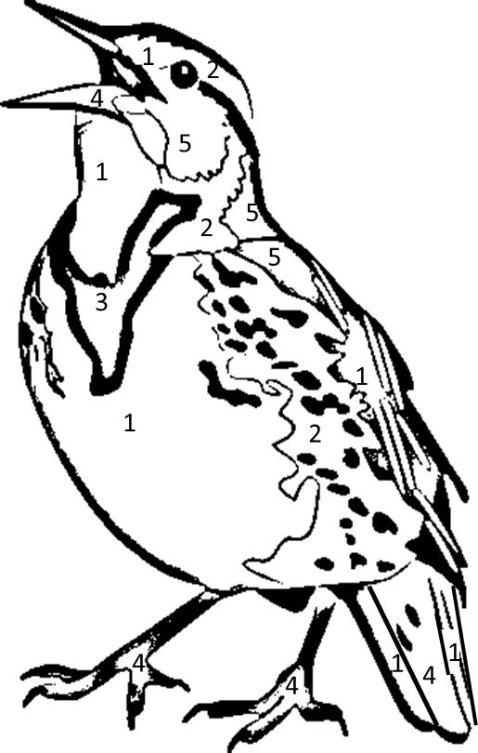

Males and females have the same coloring. Color the drawing of a western meadowlark according to chart below:

Number | Color
1 | Yellow
2 | White
3 | Black
4 | Brown
5 | Gray

Western Meadowlark image modified from : Tracey Saxby, IAN Image Library (ian.umces.edu/imagelibrary/)
Birds in California Grasslands Name_______________________________

- What do Western Meadowlarks eat?

- Why do you think Western Meadowlarks cover their nest with a grassy domed tunnel?

- Western Meadowlarks are described as year-round residents of California grasslands. What do you think the phrase “year-round resident” mean?

- According to the passage, what is the main difference between the Eastern and Western Meadowlark?

Birds in California Grasslands Name_______________________________
The Lewis and Clark Expedition (1804-1806)
The Lewis and Clark Expedition was the first American expedition to travel to the western portion of what is now the United States. They traveled from the Mississippi River to the Pacific coast at the mouth of the Columbia River in the state of Washington. Refer to the three maps below. The first two are range maps showing where the Western and Eastern Meadowlarks occur in North America. The third map shows the route traveled by the expedition. Use a separate page to write why you think they did not recognize the Western Meadowlark as a different species from the Eastern Meadowlark?
Range Map: Eastern Meadowlark
http://askabiologist.asu.edu/bird?id=204

Range Map: Western Meadowlark
http://askabiologist.asu.edu/bird?id=205

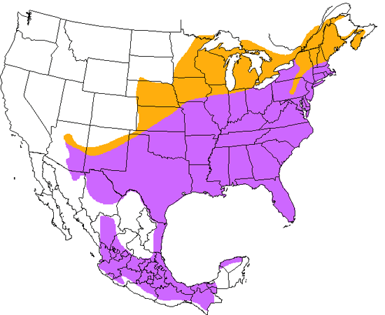
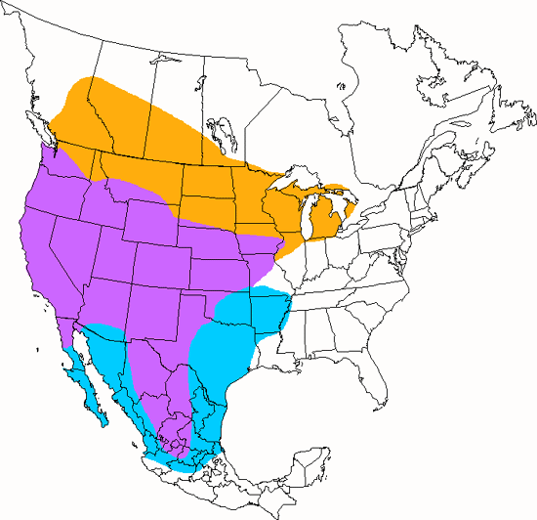
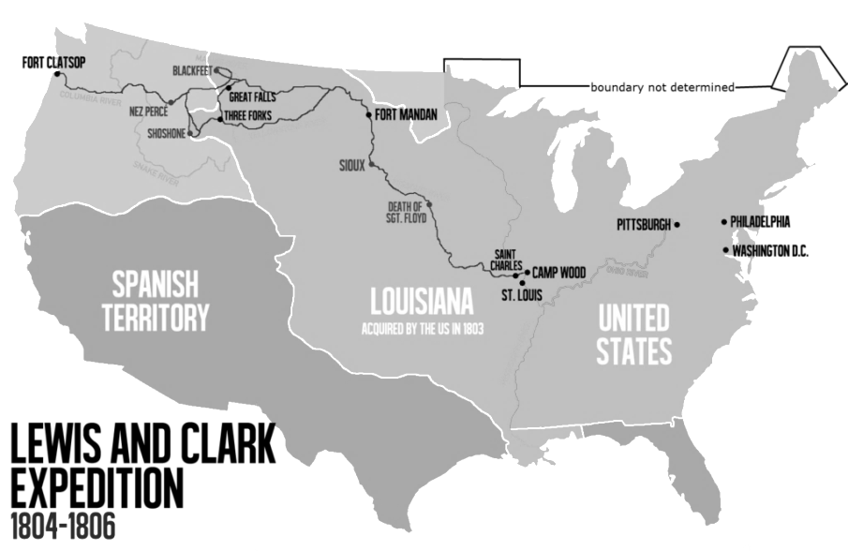

Range maps courtesy of : Dr. Biology. (2009, October 6). Western Meadowlark and Eastern Meadowlark. ASU - Ask A Biologist. Retrieved July 25, 2014 from http://askabiologist.asu.edu/bird. Creative Commons License.
Lewis and Clark Expedition map courtesy of: Victor van Werkhooven.(2014, May 22) Wikipedia. Retrieved July 25, 2014 from http://en.wikipedia.org/wiki/Lewis_and_Clark_Expedition. Public Domain.

Birds in California Grasslands Answer Key

- What do Western Meadowlarks eat?

Answers will vary.
Western meadowlarks eat seeds, insect, grubs and worms.

- Why do you think Western Meadowlarks cover their nest with a grassy domed tunnel?

Answers will vary.
Western Meadowlarks cover their nests to hide them from predators.

- Western Meadowlarks are described as year-round residents of California grasslands. What do you think the phrase “year-round resident” mean?

Answers will vary. A year round resident lives in the same place all year unlike many other bird species that have seasonal migrations to other areas with abundant food and nesting resources.

- According to the passage, what is the main difference between the Eastern and Western Meadowlark?

The Western Meadowlark has a musical flutelike song.
Learn more and compare the sounds of the two meadowlarks:
Western Meadowlark: http://www.allaboutbirds.org/guide/western_meadowlark/sounds.
Eastern Meadowlark: http://www.allaboutbirds.org/guide/Eastern_Meadowlark/sounds.

The Lewis and Clark Expedition (1804-1806)
Answers will vary.

